[**https://tpchd.org/healthy-places/food-safety/inspection-rating/**](https://tpchd.org/healthy-places/food-safety/inspection-rating/)

**Food Safety Inspection Rating**

All food establishments are required to post a food safety rating sign at all entrances and drive-thru windows.

**Why food safety signs?**

We inspect restaurants, food trucks, caterers, schools, and other places that serve food. We provide food safety inspection, closure and outbreak information on our website so everyone can make informed choices. But few people know about or use these reports.

**Signs make it easier for people to understand and use food safety inspection ratings.**

**Inspection rating signs**

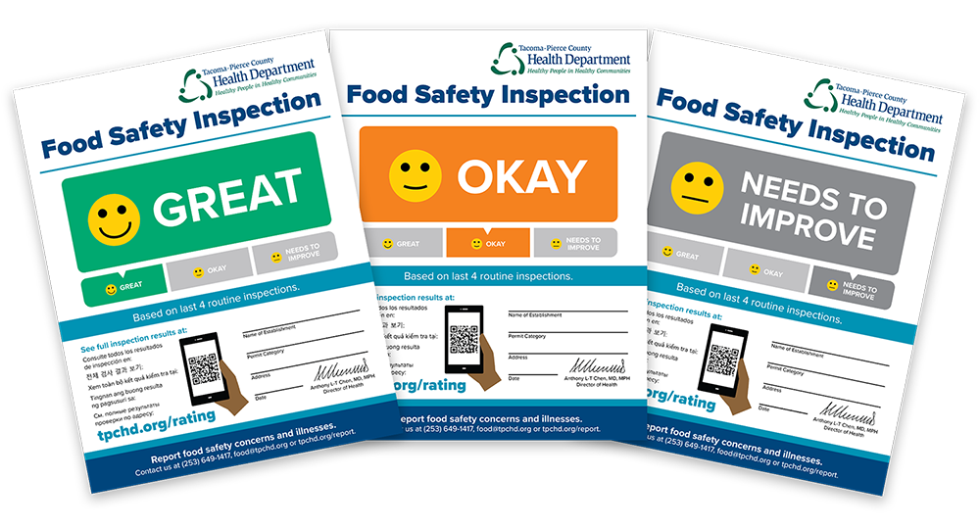

**Categories**



Great—Very few or no concerns.



Okay—Some concerns.



Needs to improve—Many or repeated concerns.

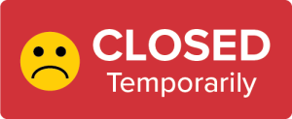

Closed—A pattern of food safety problems or an immediate health risk like:

* Lack of refrigeration.
* Fire, flood or power outage.
* No hot water.
* Sewage backup.
* Restroom not working.
* No permit.
* Foodborne illness and other reasons.



New—New restaurants don’t have a rating yet. They will get one after they have more inspections. You’ll still be able to see how they did on their [inspections](https://eco.tpchd.org/#/pa1/search).

**Watch one of our food safety inspectors talk about the rating signs.**

**Are you a food establishment?**

Follow these [instructions](https://tpchd.org/wp-content/uploads/2023/12/How-to-post-your-food-safety-rating-sign.pdf) to post your rating sign.

**Questions?**

Contact us at (253) 649-1417 or [food@tpchd.org](mailto:food@tpchd.org).